**LABORATORIES**

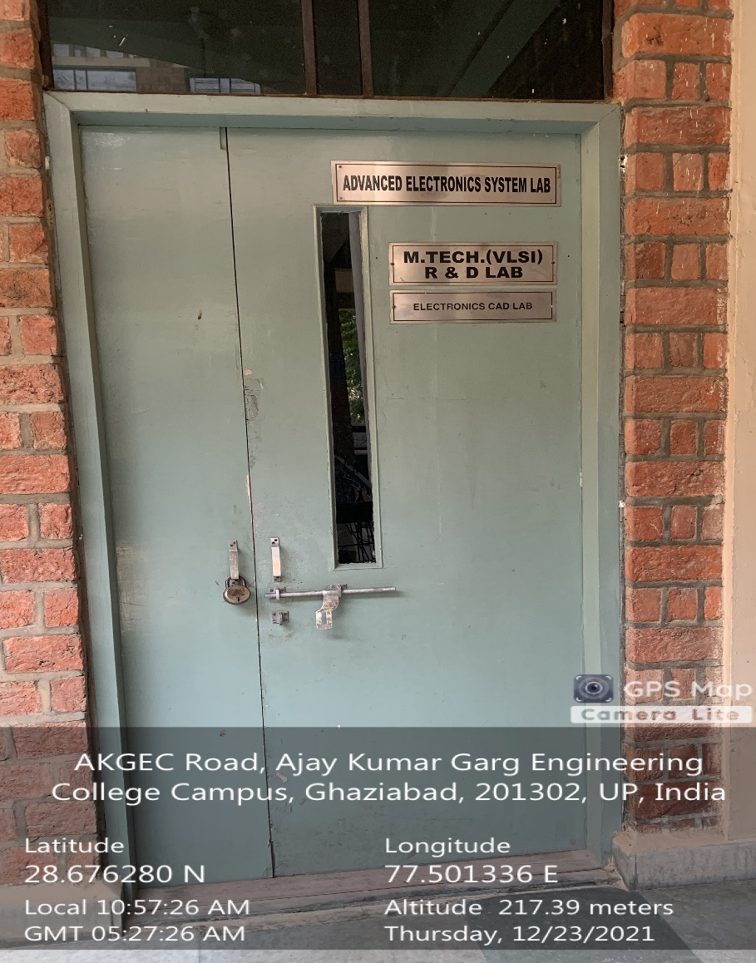

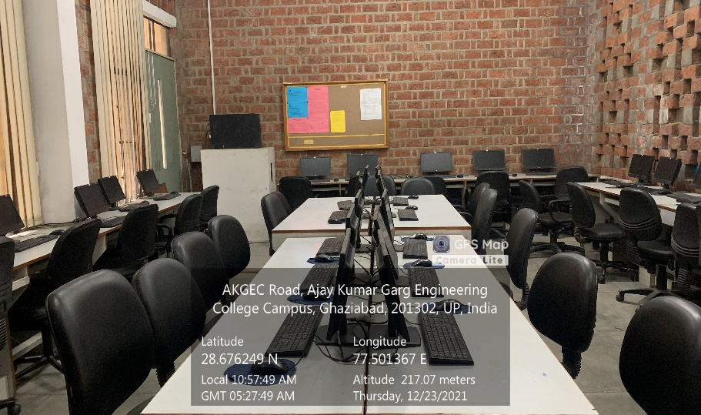

**Back Block, First Floor, M.TECH. ECE LAB**

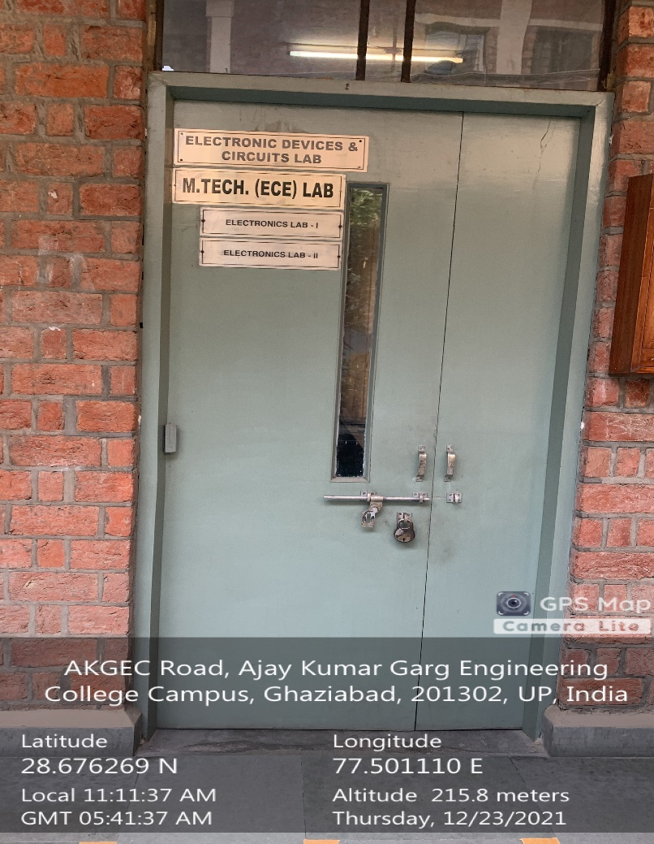

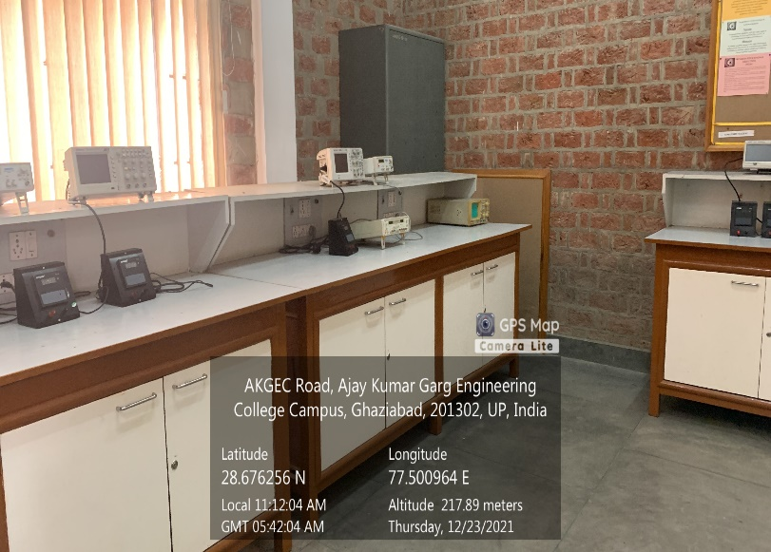

**Back Block, Second Floor, M.TECH. ECE SIMULATION AND RESEARCH LAB-II**

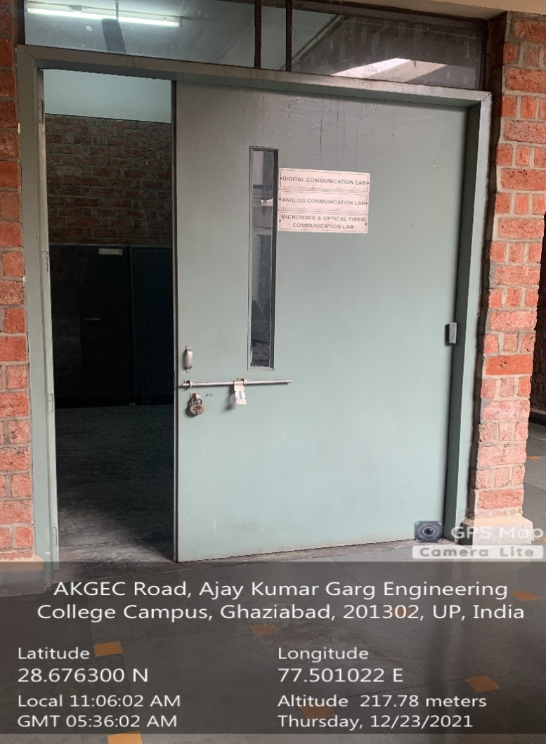

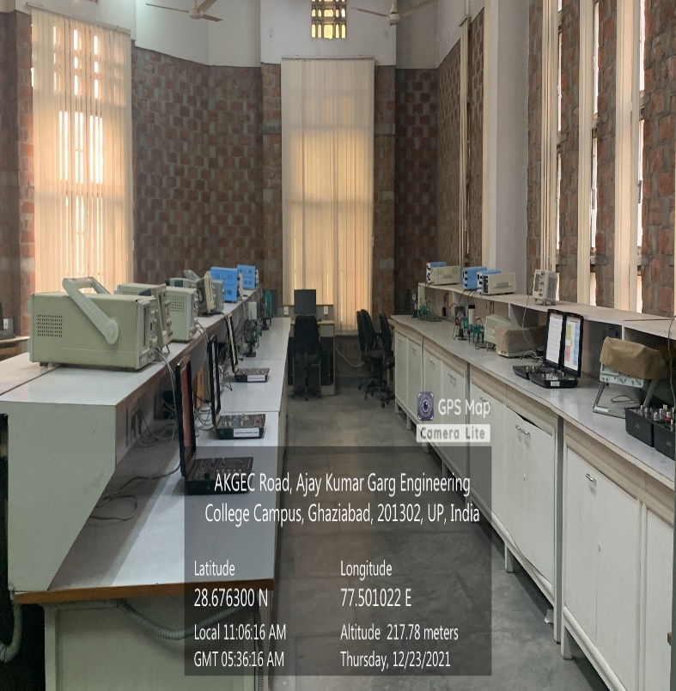

**Back Block, First Floor, ANALOG CIRCUITS LAB**

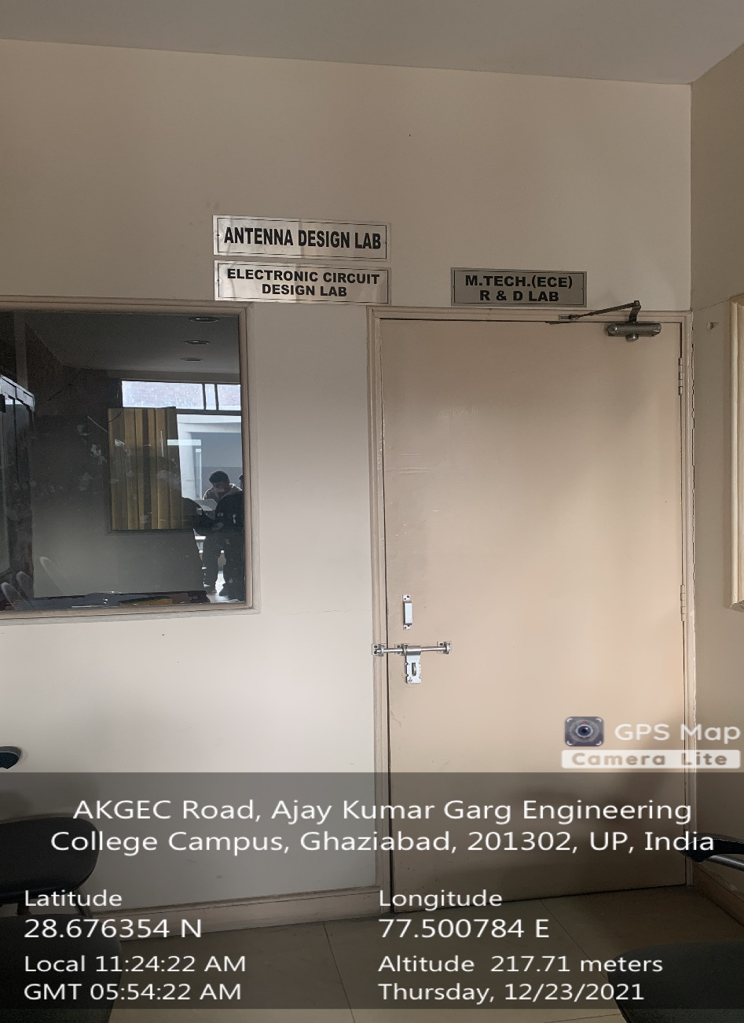

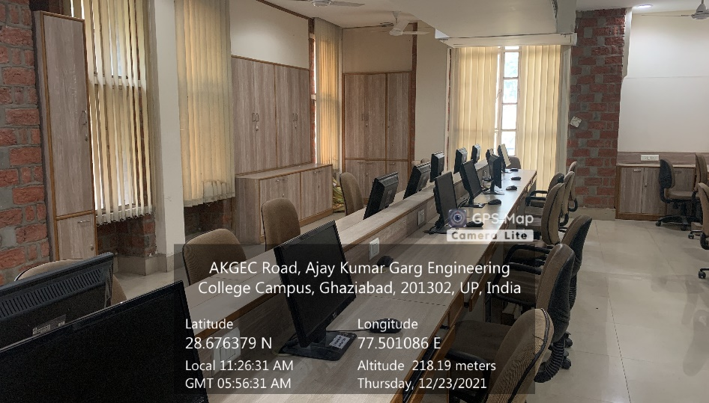

**Back Block, First Floor, ANTENNA & MICROWAVE ENGINEERING LAB**

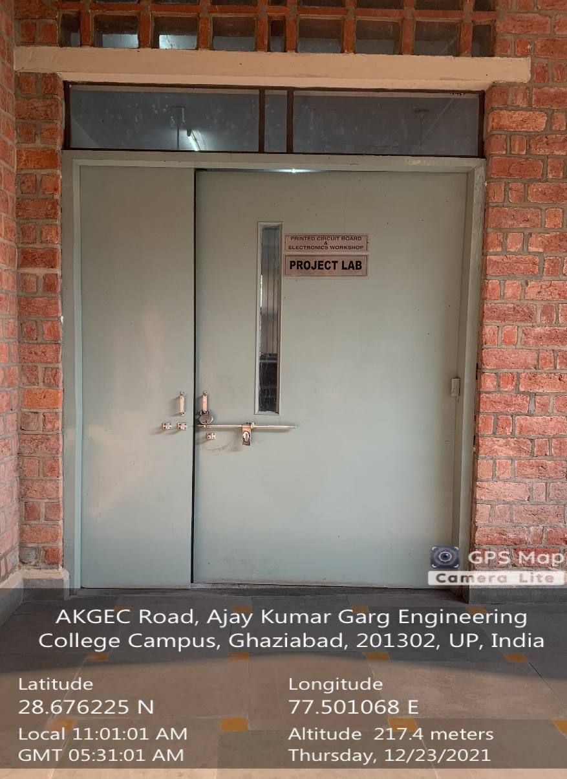

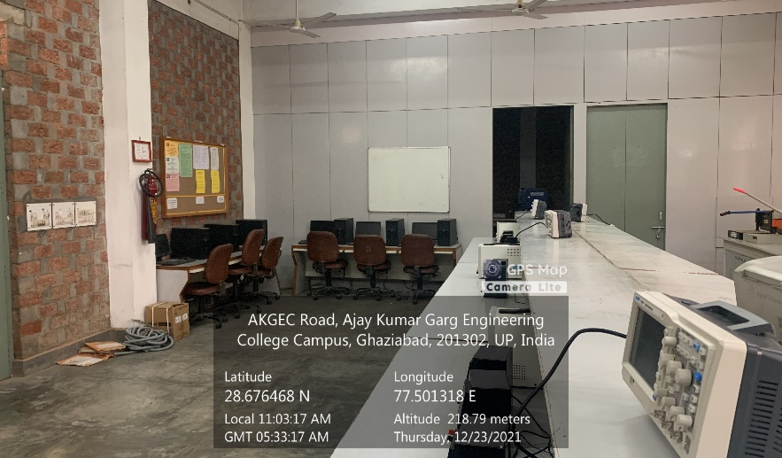

**Back Block, First Floor, BASICS ELECTRONICS & ELECTRONIC DEVICES LAB**



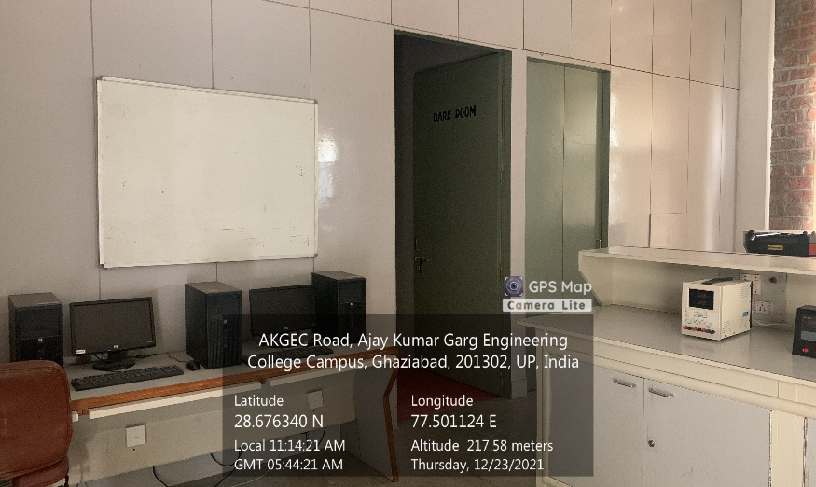

**Back Block, First Floor, BASICS ELECTRONICS & PCB DESIGN CUM MINI PROJECT LAB**

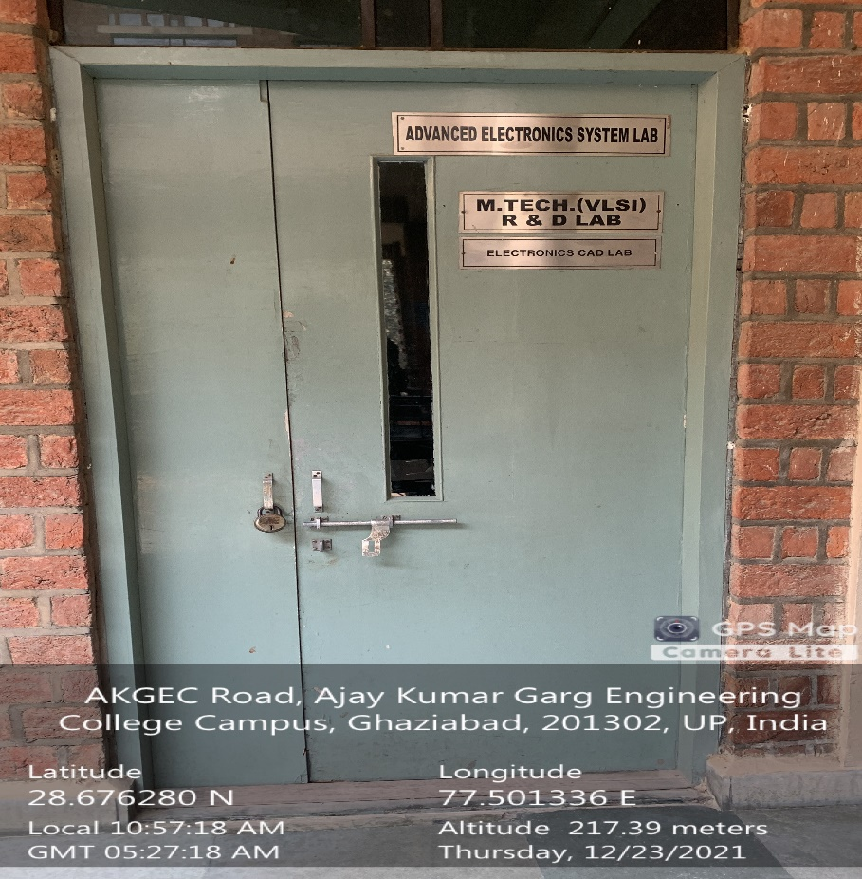

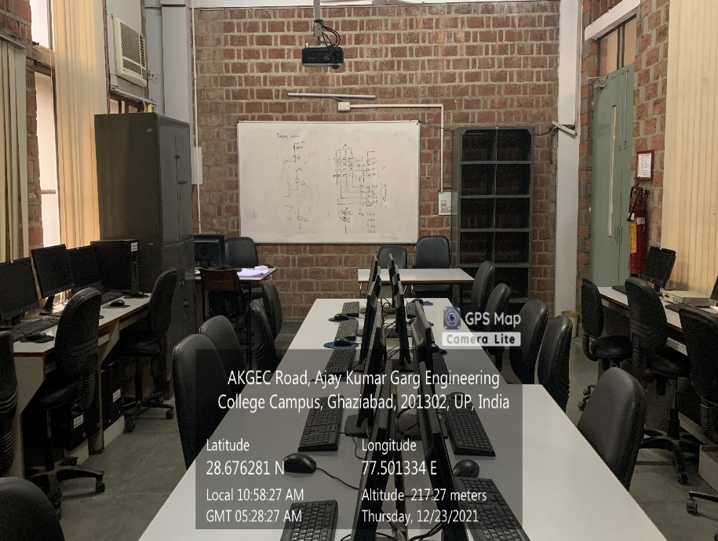

**Back Block, First Floor, CAD OF ELECTRONICS LAB**

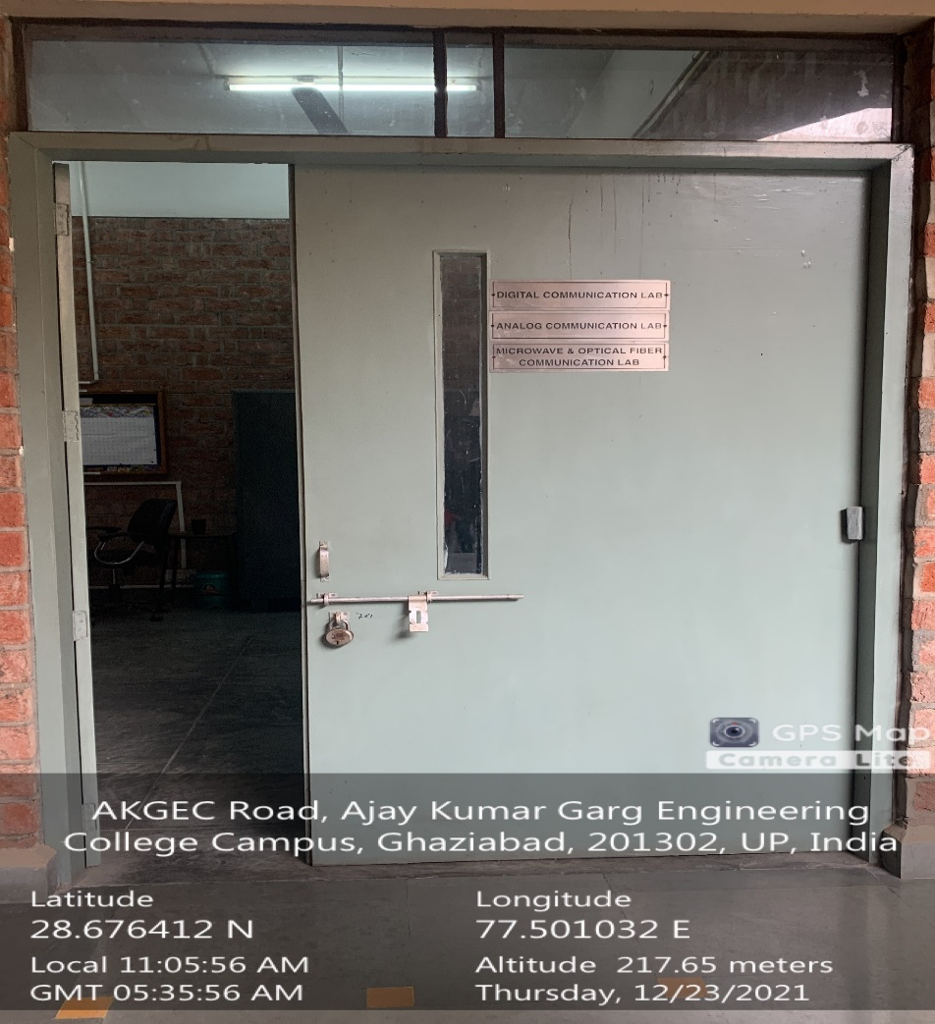

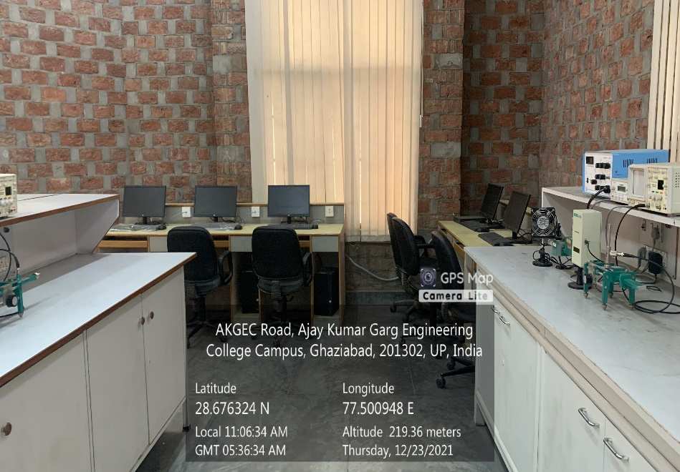

**Back Block, First Floor, COMMUNICATION ENGG. LAB**

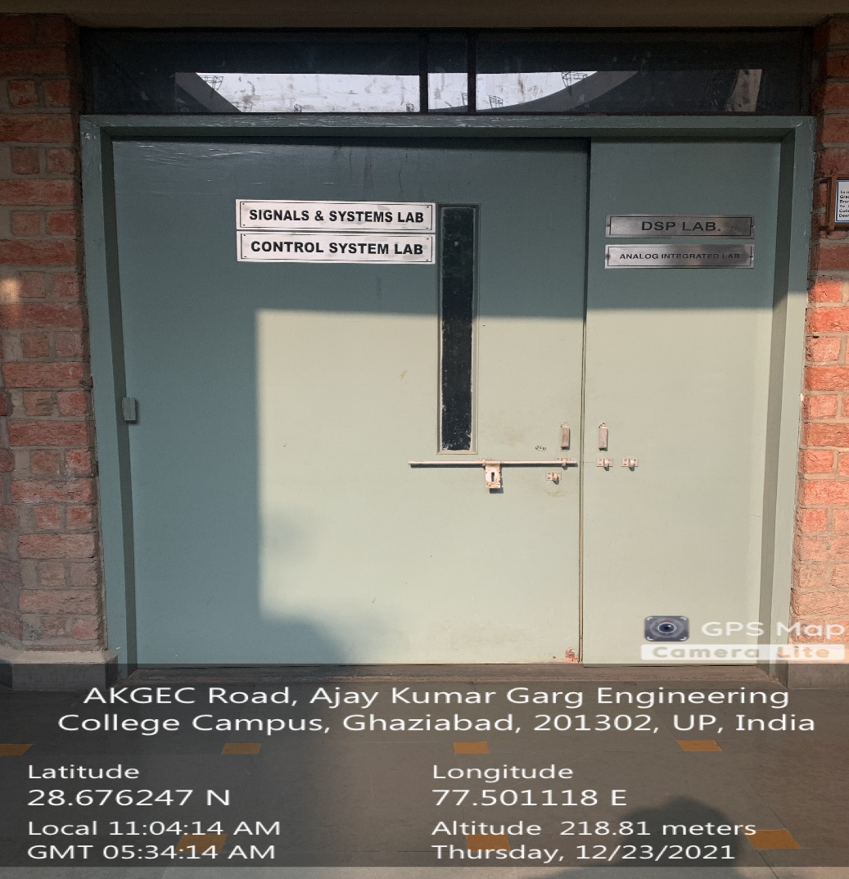

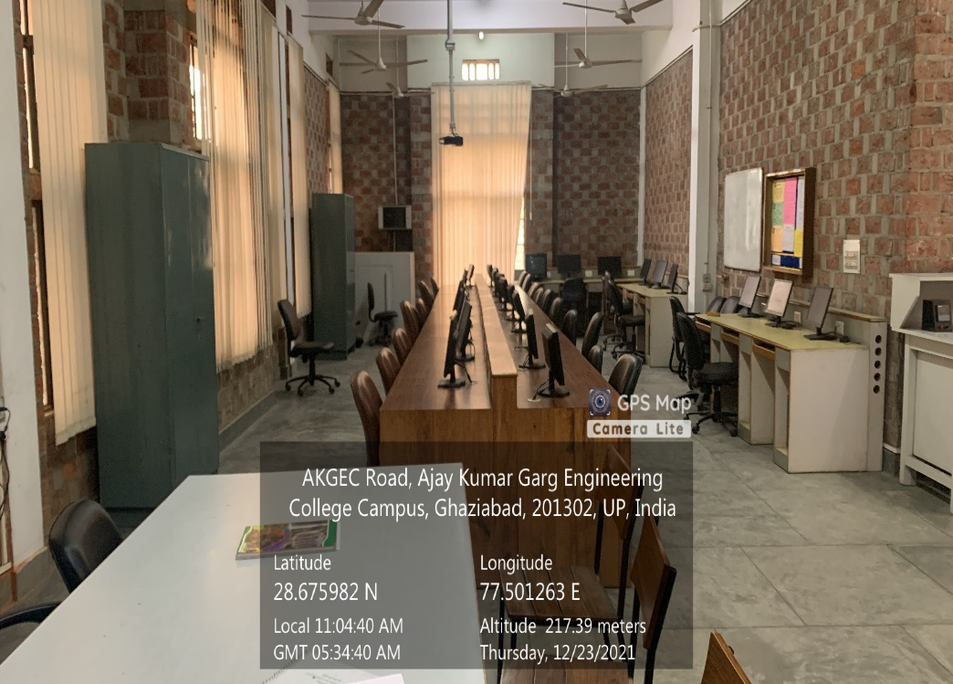

**Back Block, First Floor, CONTROL SYSTEM LAB-1**

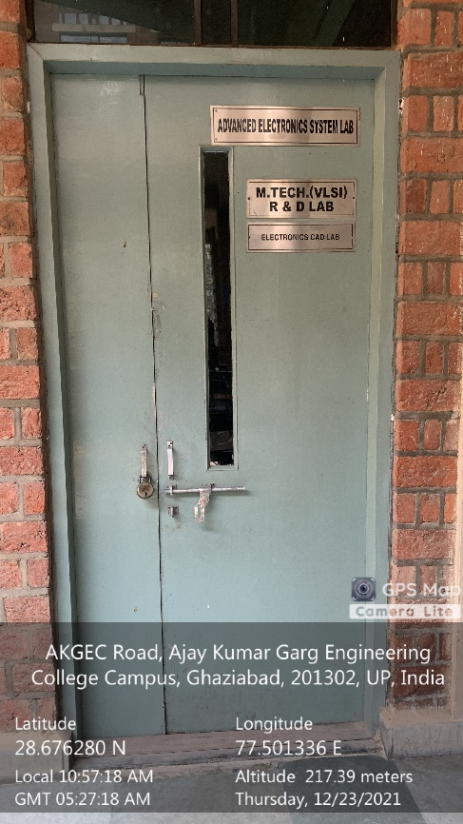

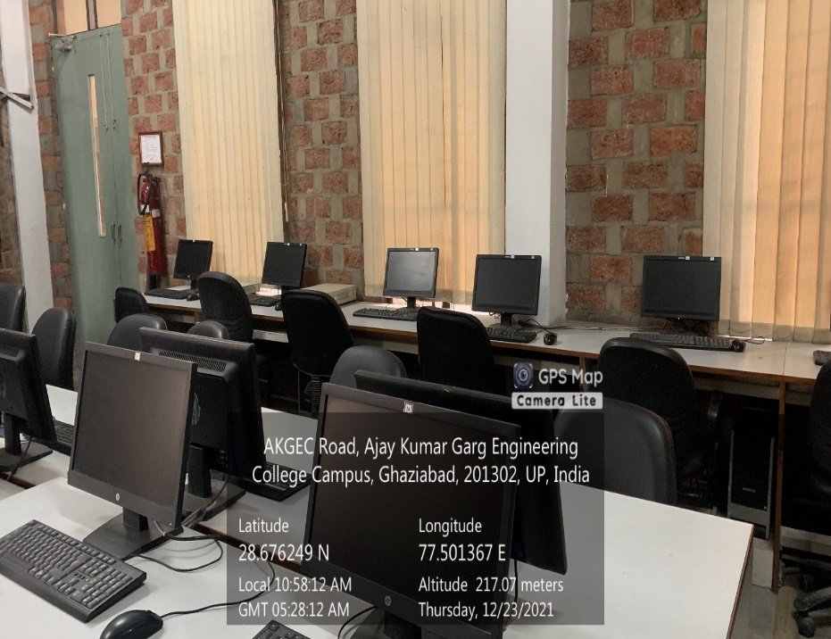

**Back Block, Second Floor, DATA STRUCTURE AND PROGRAMMING LAB**

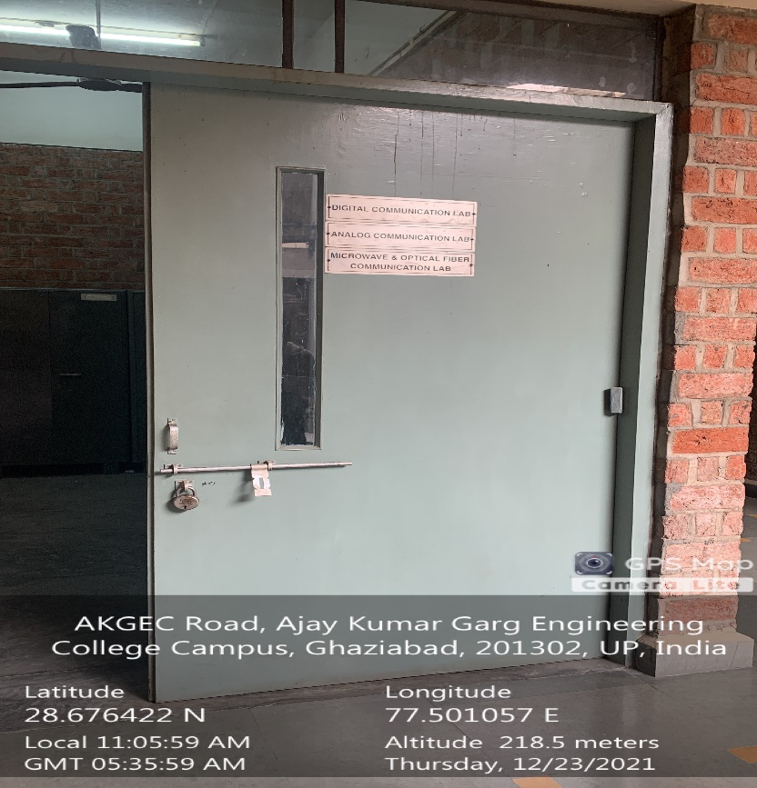

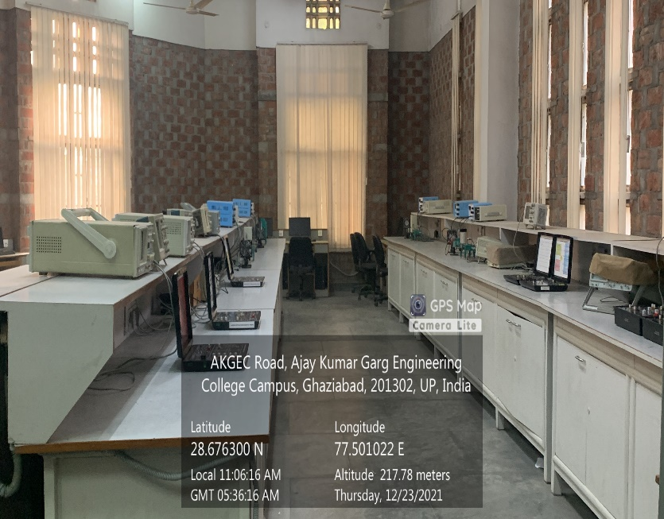

**Back Block, First Floor, DIGITAL COMMUNICATION LAB**

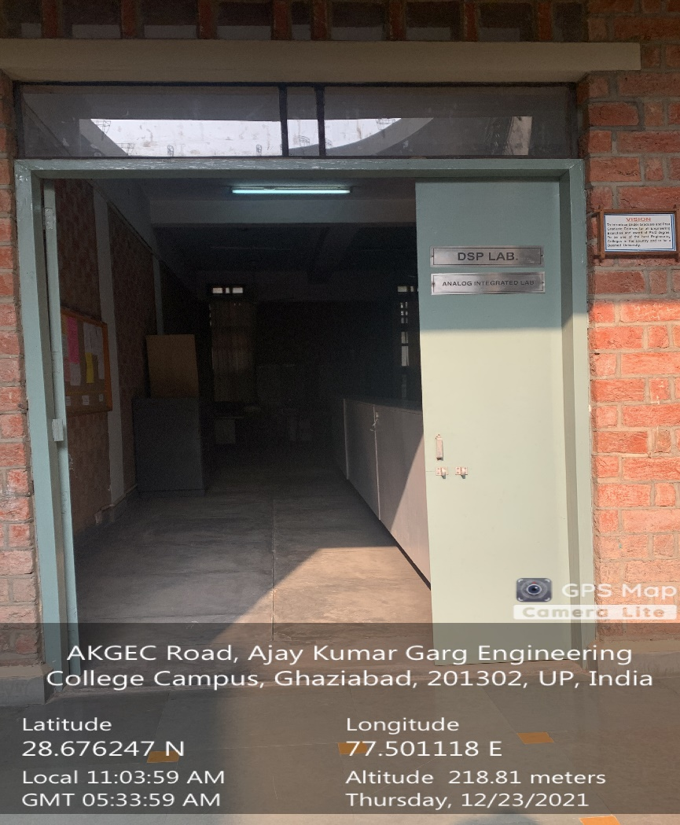

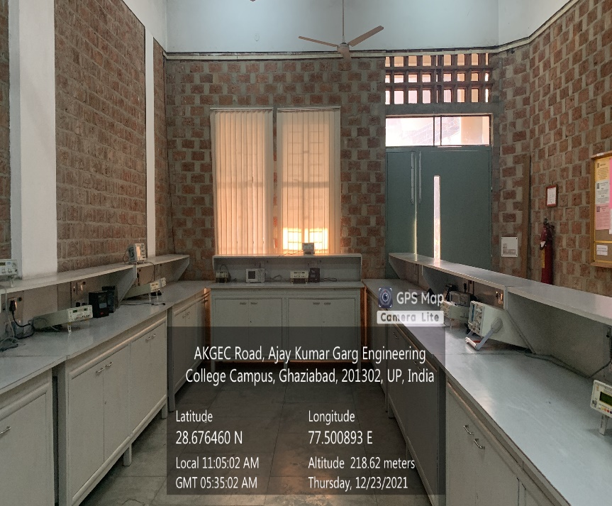

**Back Block, First Floor, DIGITAL SIGNAL PROCESSING (DSP) LAB**

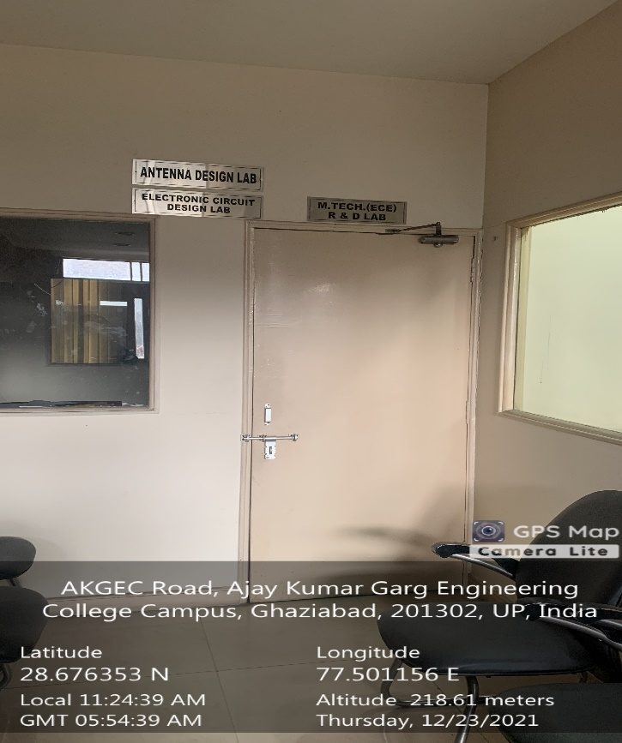

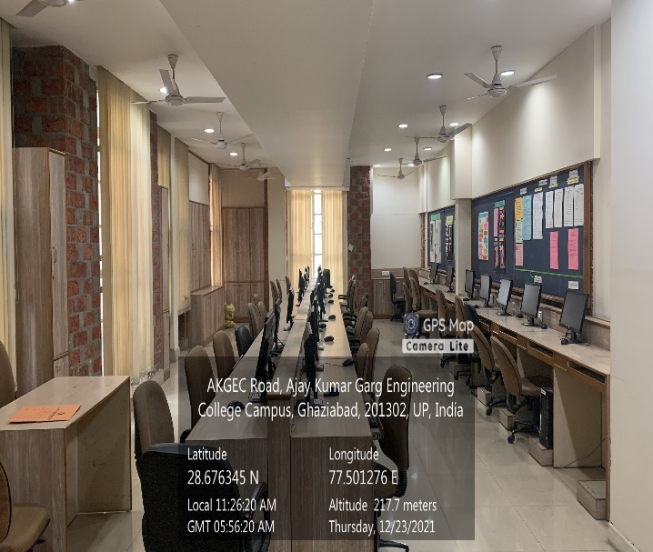

**Back Block, Second Floor, DIGITAL SYSTEM DESIGN LAB**

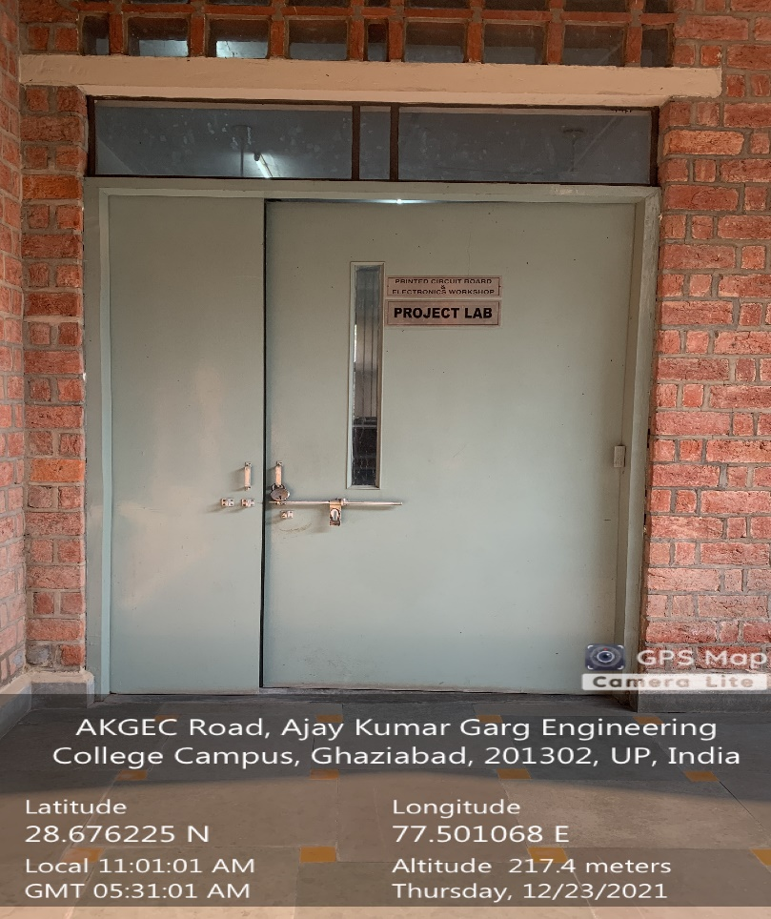

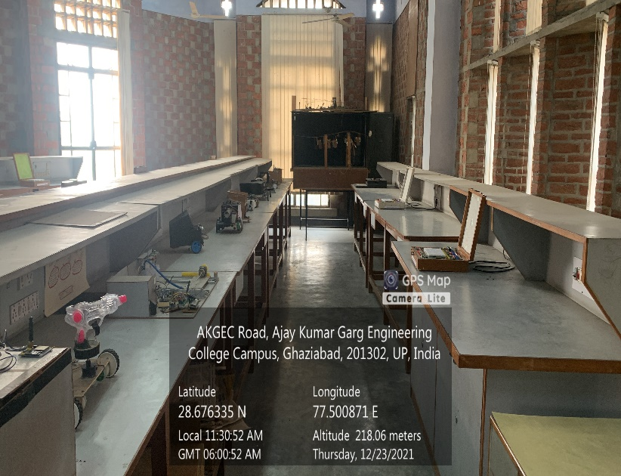

**Back Block, Second Floor, ECE PROJECT LAB**

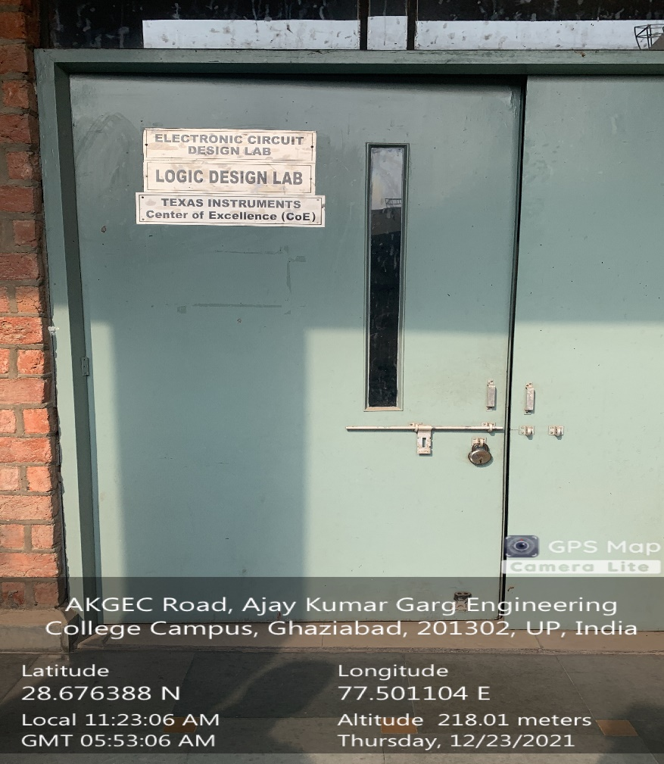

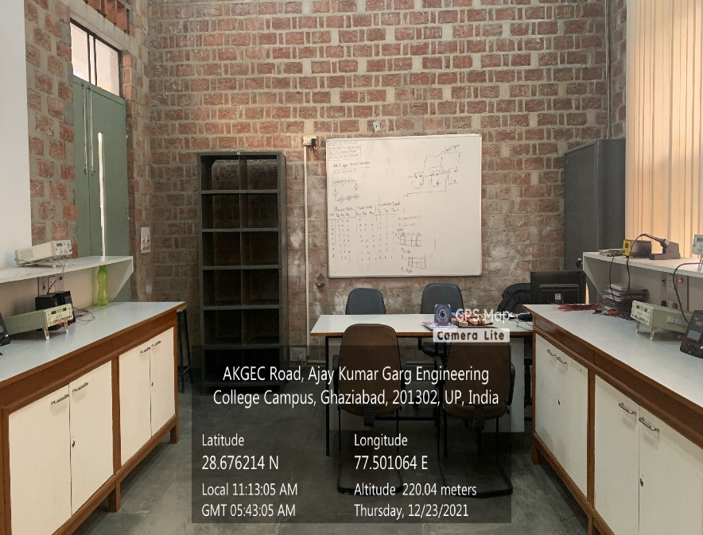

**Back Block, Second Floor, ELECTRONIC CIRCUIT DESIGN LAB**

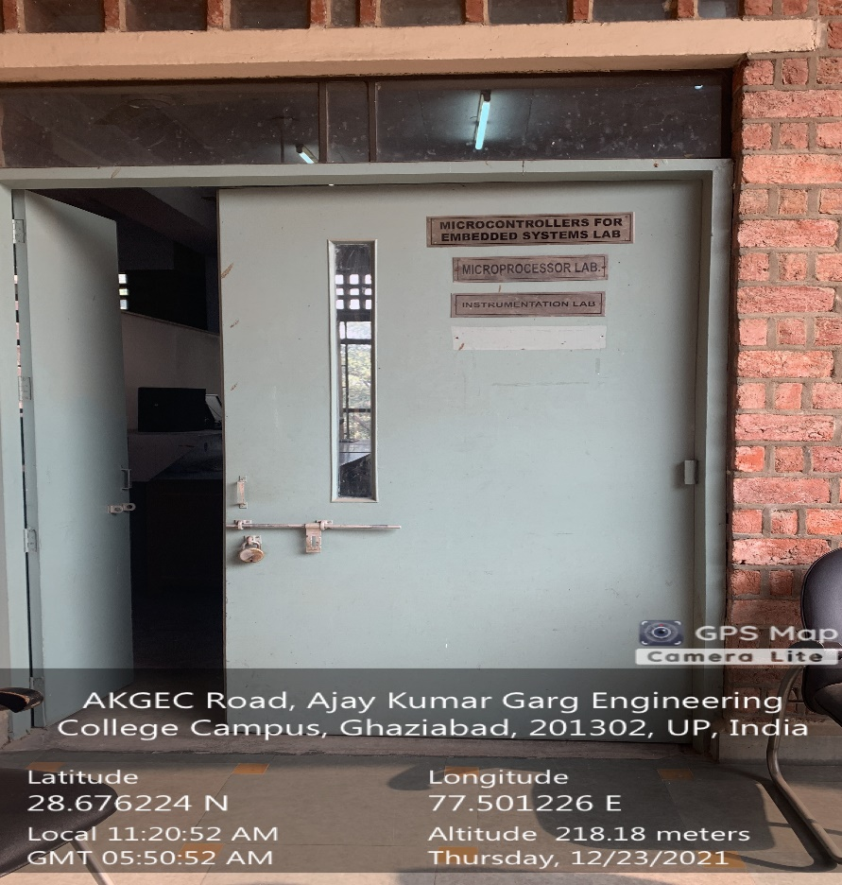

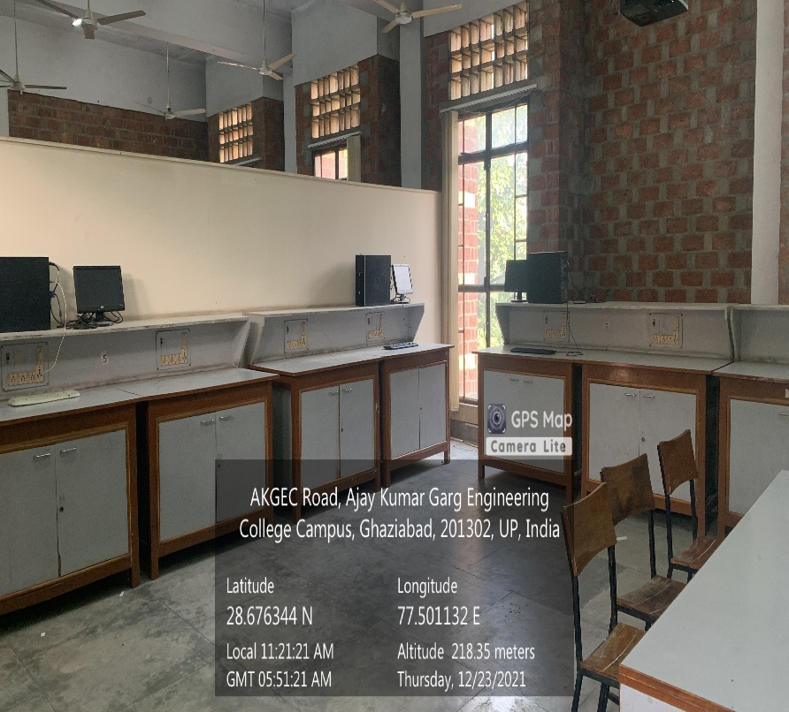

**Back Block, Second Floor, ELECTRONICS MEASUREMENT & INSTRUMENTATION LAB**

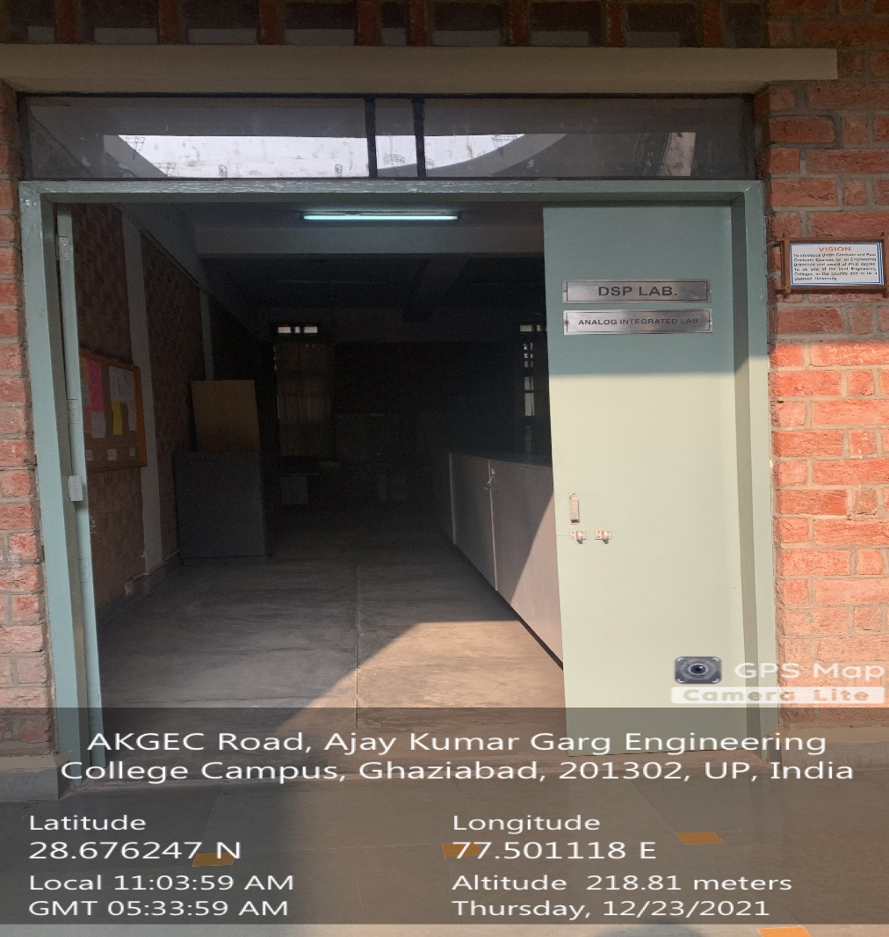

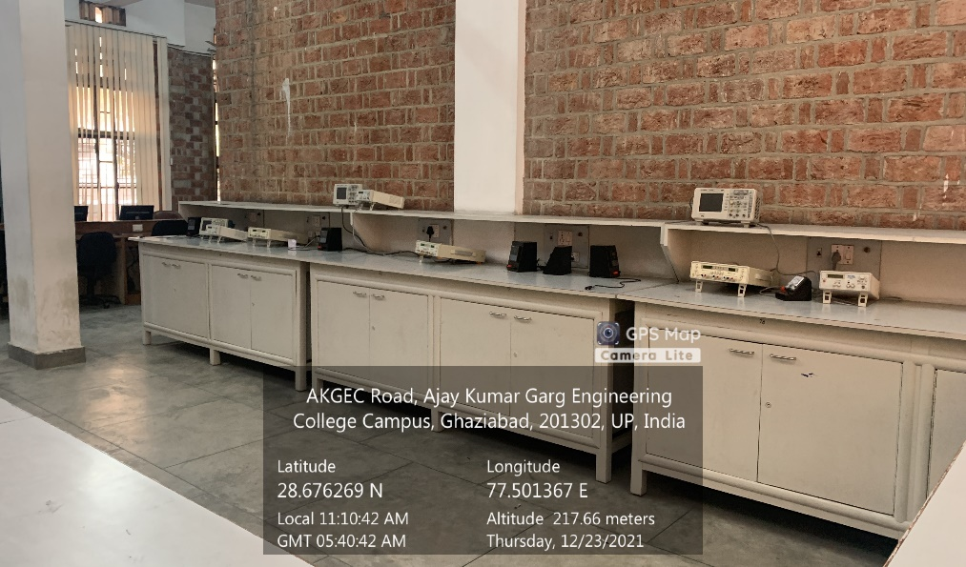

**Back Block, First Floor, INTEGRATED CIRCUITS LAB**

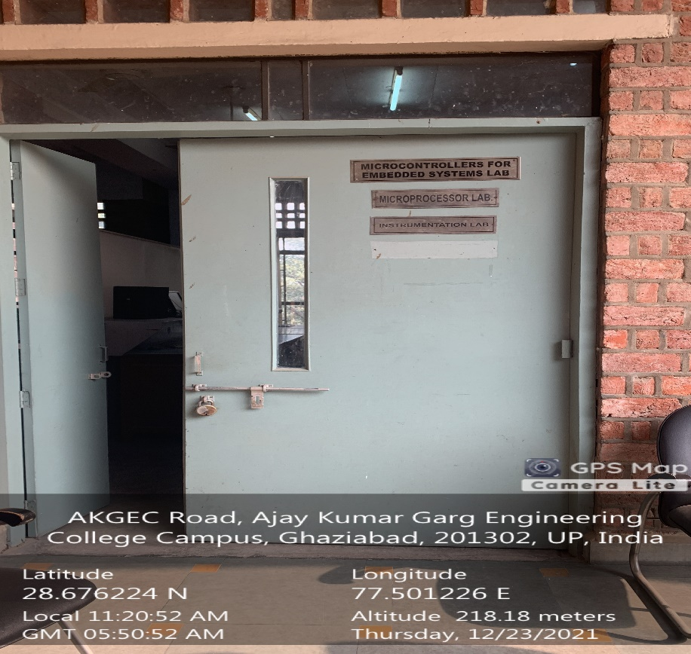

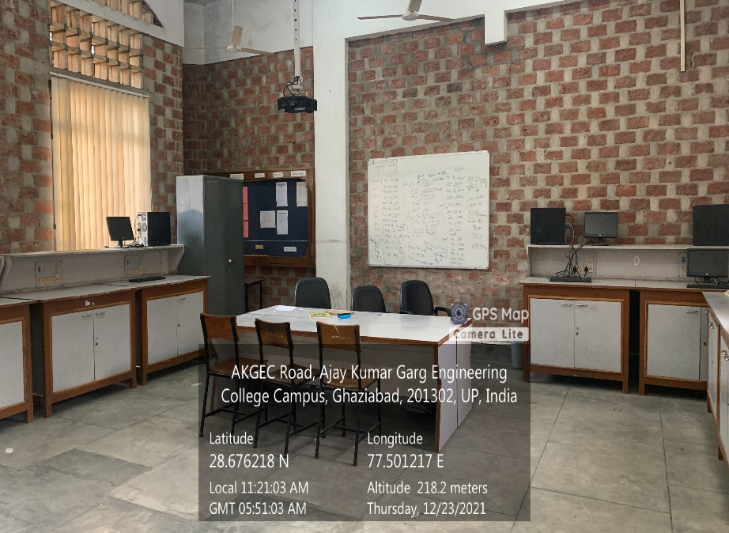

**Back Block, Second Floor, MICROCONTROLLERS FOR EMBEDDED SYSTEM LAB**

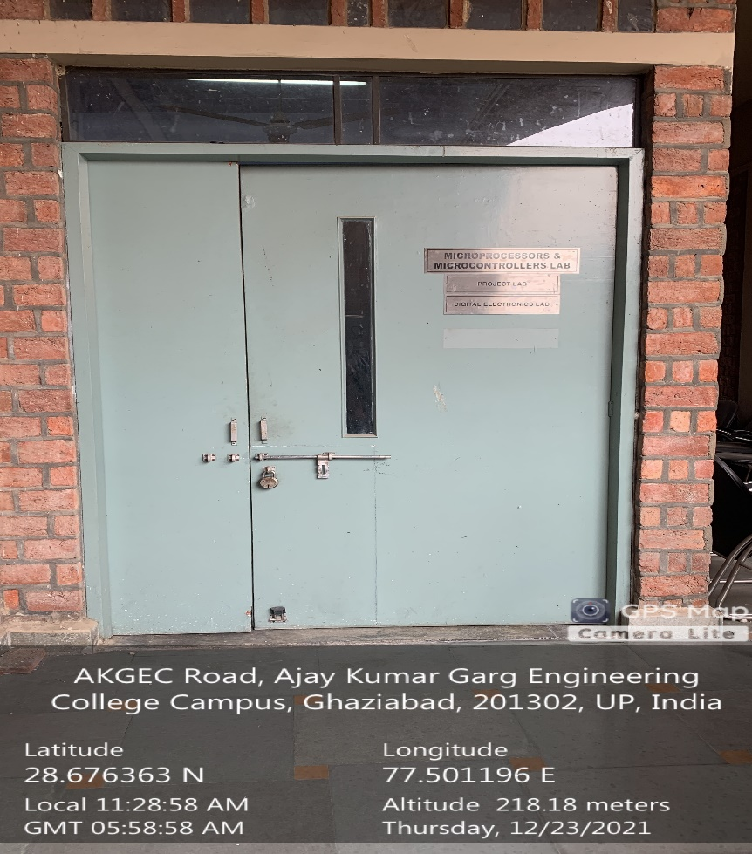

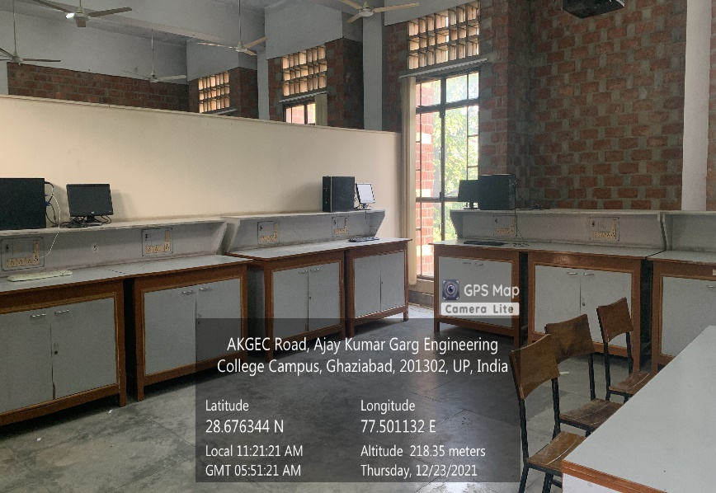

**Back Block, Second Floor, MICROPROCESSORS & MICROCONTROLLERS LAB**

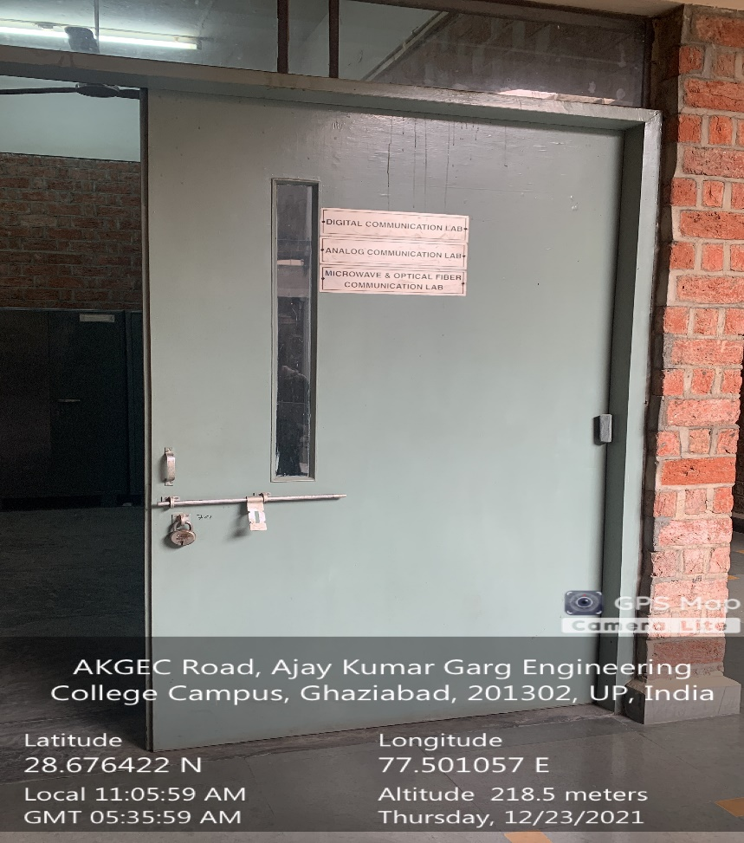

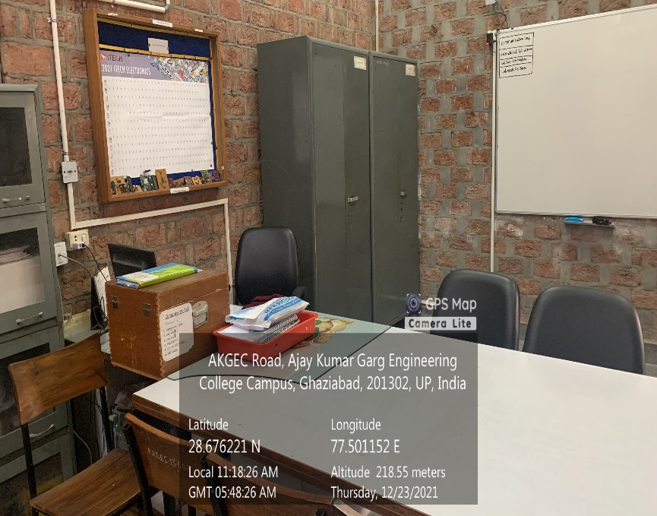

**Back Block, First Floor, OPTICAL COMMUNICATION & NETWORKING LAB**

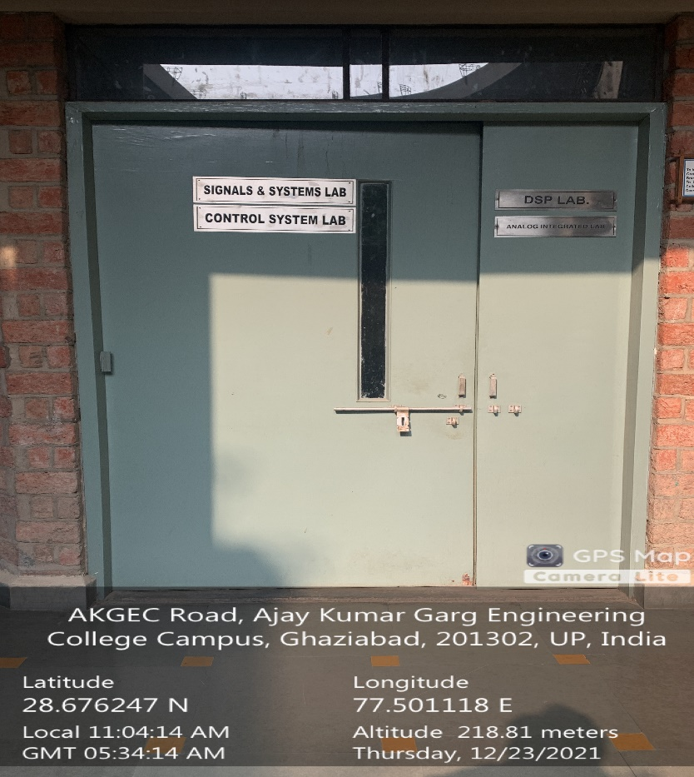

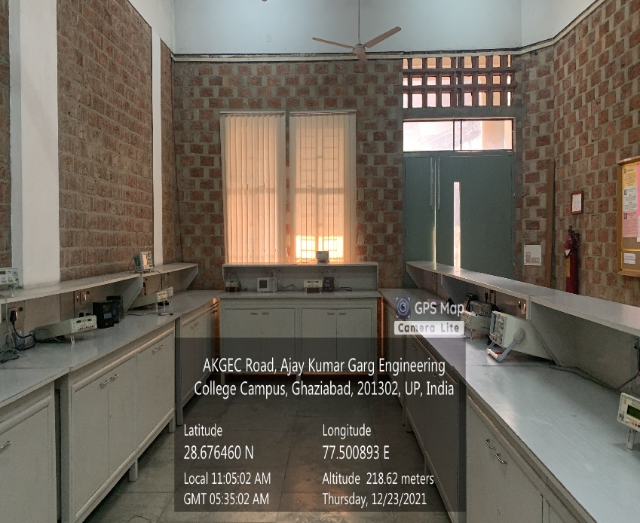

**Back Block, First Floor, SIGNALS & SYSTEMS LAB**

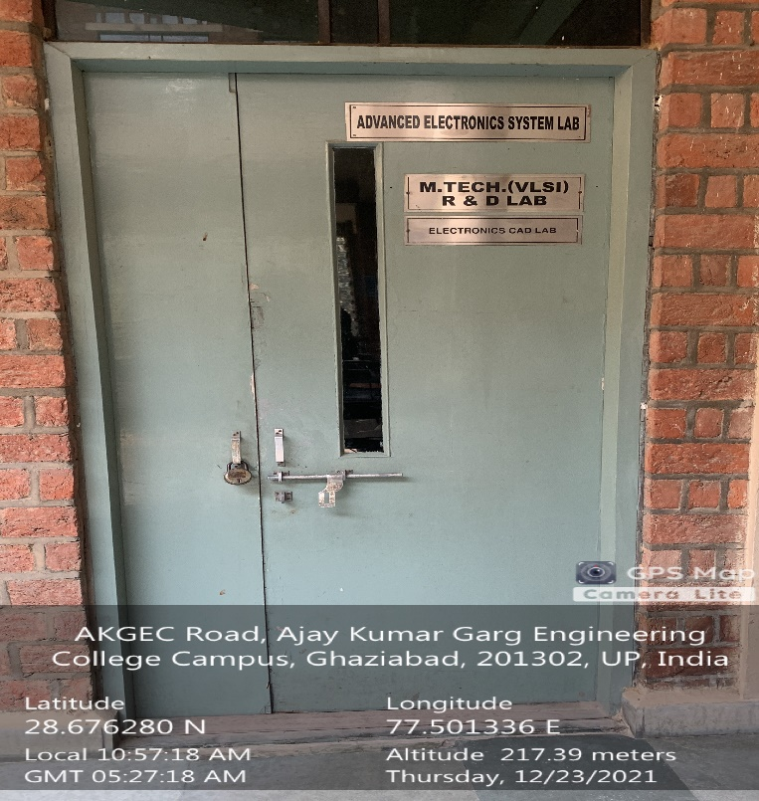

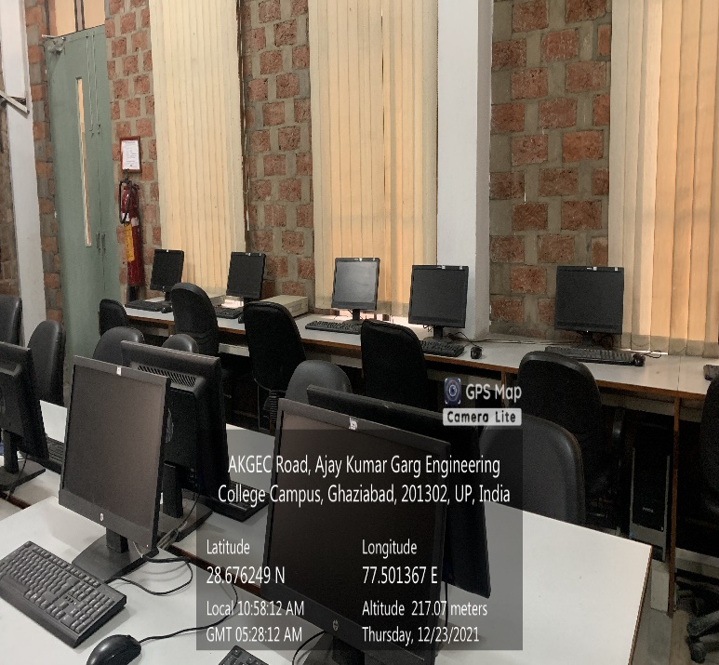

**Back Block, First Floor, M.TECH. ECE SIMULATION AND RESEARCH LAB-I**